To aid the submission process, we wish to provide you with instructions and illustrations of how to name and save your assignment submission. This way of naming assignment submissions has always been encouraged; however this year is being enforced to prevent hundreds of hours being waster manually renaming thousands of files prior to exam boards.

Once you have completed your assignment and ensured that the first page of this assignment includes the Assignment Cover Page Template (Moodle- Forms Forms Forms!) in illustration 1., Save as a PDF) then name your submission using the instructions on illustration 2. To rename a file see over leaf.
Illustration 2.

As an example, the correct way to name your submission is;

Durham TMM1437 (QDC) Component 1 999999
Newman QF406 (QRC) Component 1 999999

Module Code | Group | Component  (if applicable and you have multiple components to this module) | Student Number | File type
TMM1437 | (QDC) | Component 1 | 999999 | .pdf
QF406 | (QDC) | Component 1 | 999999 | .pdf

Illustration 1.

If you do not name and save your assignment submission correctly (using PDF), Registry will contact you to inform you that your submission has been reverted back to draft on Moodle. This will enable you to change the submission file name and resubmit it. You will not incur any penalty for having to resubmit this piece of work past the 1pm deadline. Relevant information on naming and saving your assignment submission is detailed on Page 8 in the Academic Handbook. If you need any guidance, please contact the Registry Office directly.

We trust this information supports you and wish you well with you submission.

TO RENAME A FILE 1.:
1. Open the document in question. Go the FILE menu and choose “SAVE AS”
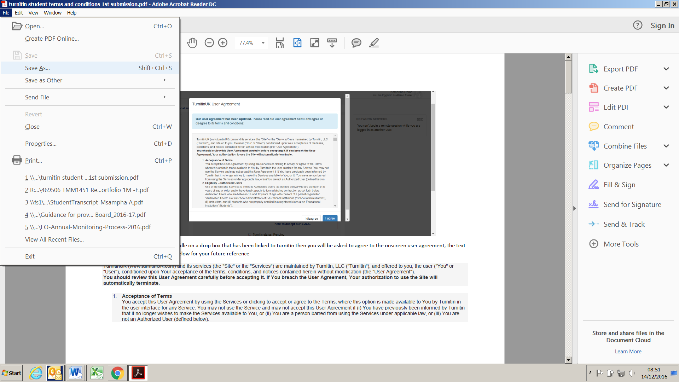

2. You MAY get this interim option:
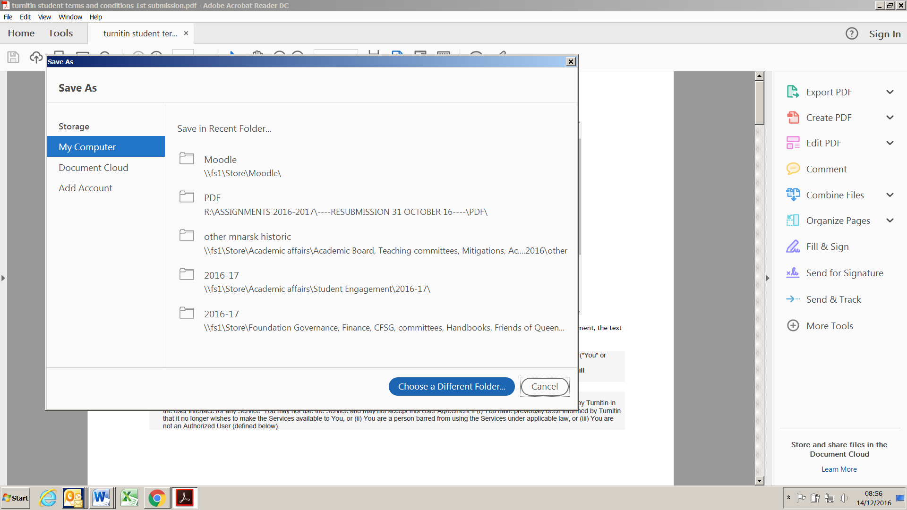

3. If you get this option press “CHOOSE A DIFFERENT FOLDER” and this will take you to the more normal “Save As” View.
If you don’t see this screen go straight to point 3 below:

3. Stage 3 the Save As Screen – this allows you to
A. Save a Copy (your final master copy) somewhere appropriate in your personal filing system (by navigating through the relevant folders on the right of your screen) and
B. In the “FILE NAME” box allows you to rename your file according to the convention on page 1.
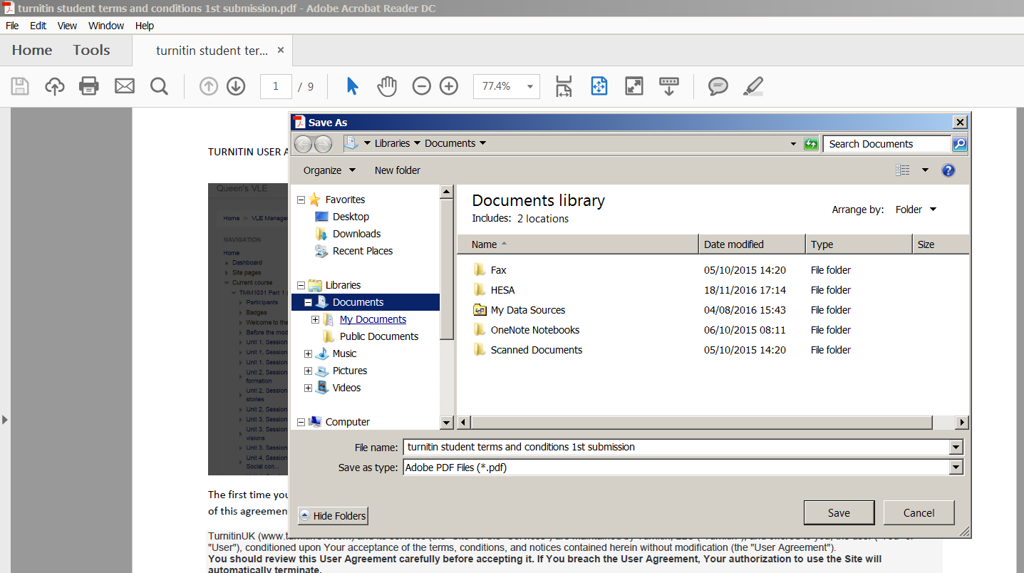
4. Press “SAVE” this will save the file in the location you have chosen here and with the new name you have given it.

HOW TO RENAME A FILE 2:
1. Go to “My Computer”, “My Documents” or START Menu (PC) and “Documents” to open a folder on your computer: 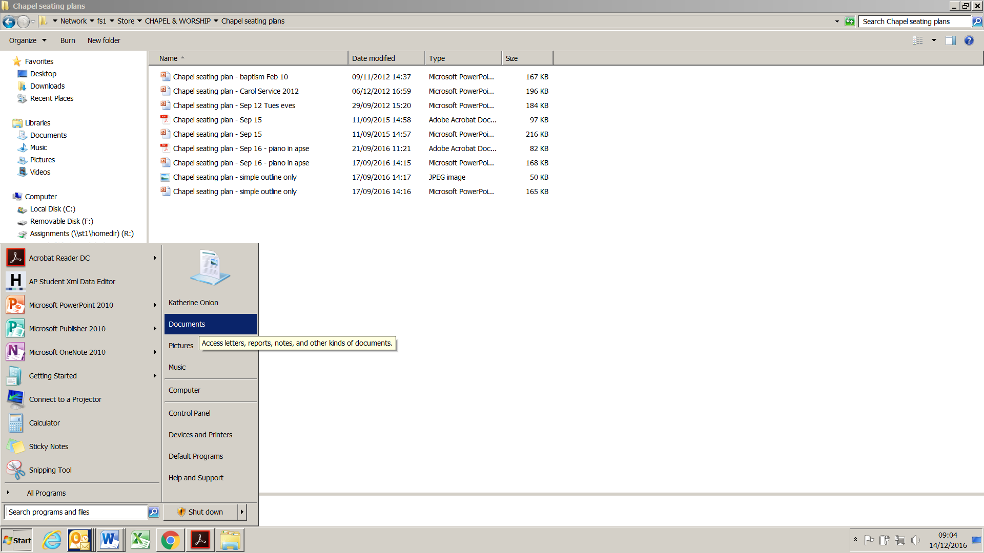

2. Once in there highlight the document you wish to rename (don’t open it).
3. Right click with your mouse, over the highlighted file to get this menu, and choose “RENAME”
4. The name will highlight and your cursor will appear in the name - You can now type the new title, and press “RETURN” on your keyboard to save this.

To rename a file when you come to upload a document on Moodle see the guide called: Renaming Summative Submissions on Moodle

