How to get to the Academic Reps Forum Page
1. Log onto Moodle. 2. Choose Chapel and Centre Information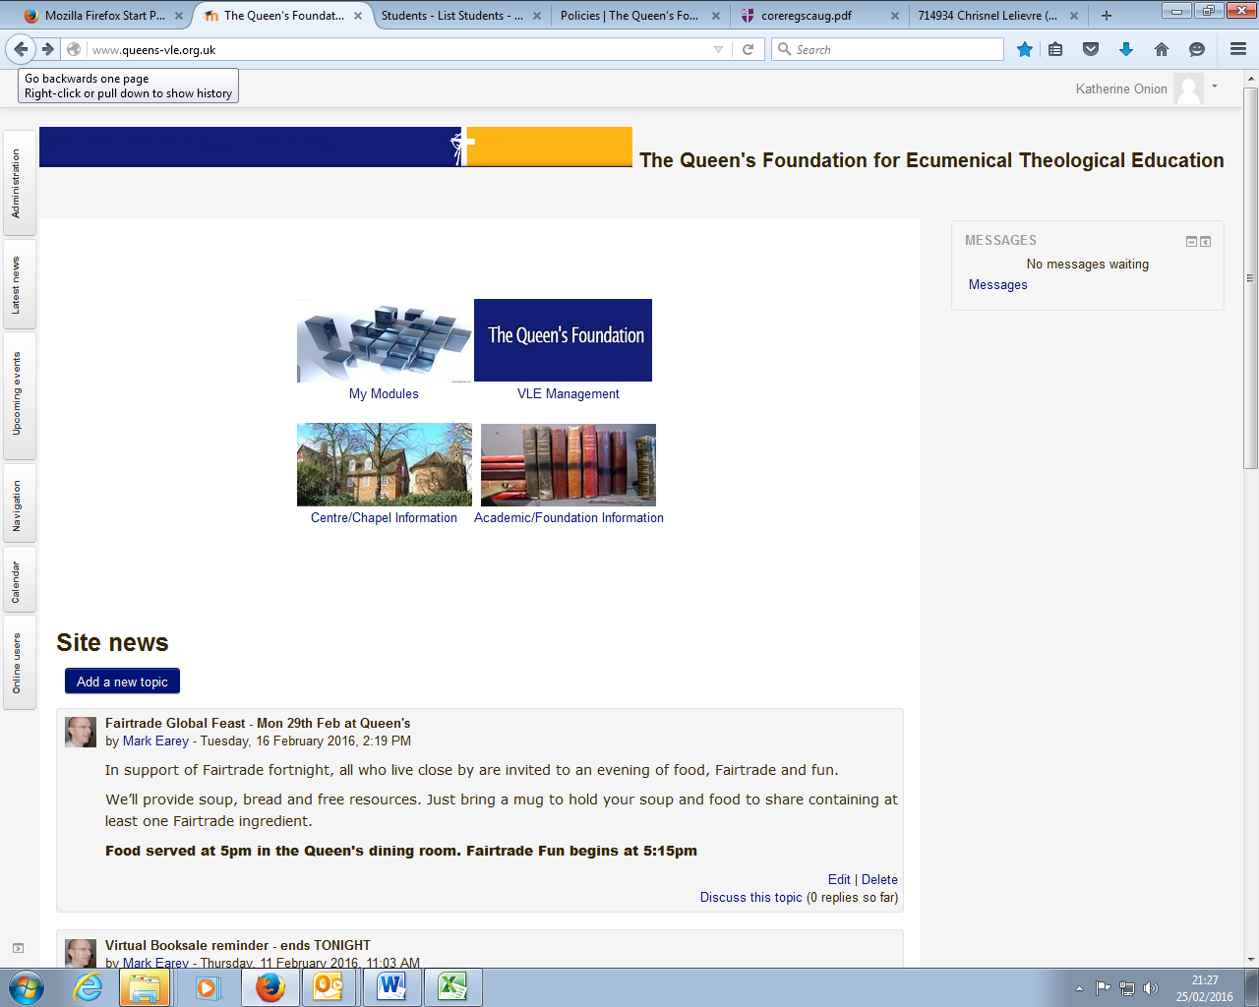

3. We are under Community and Forums Page:
: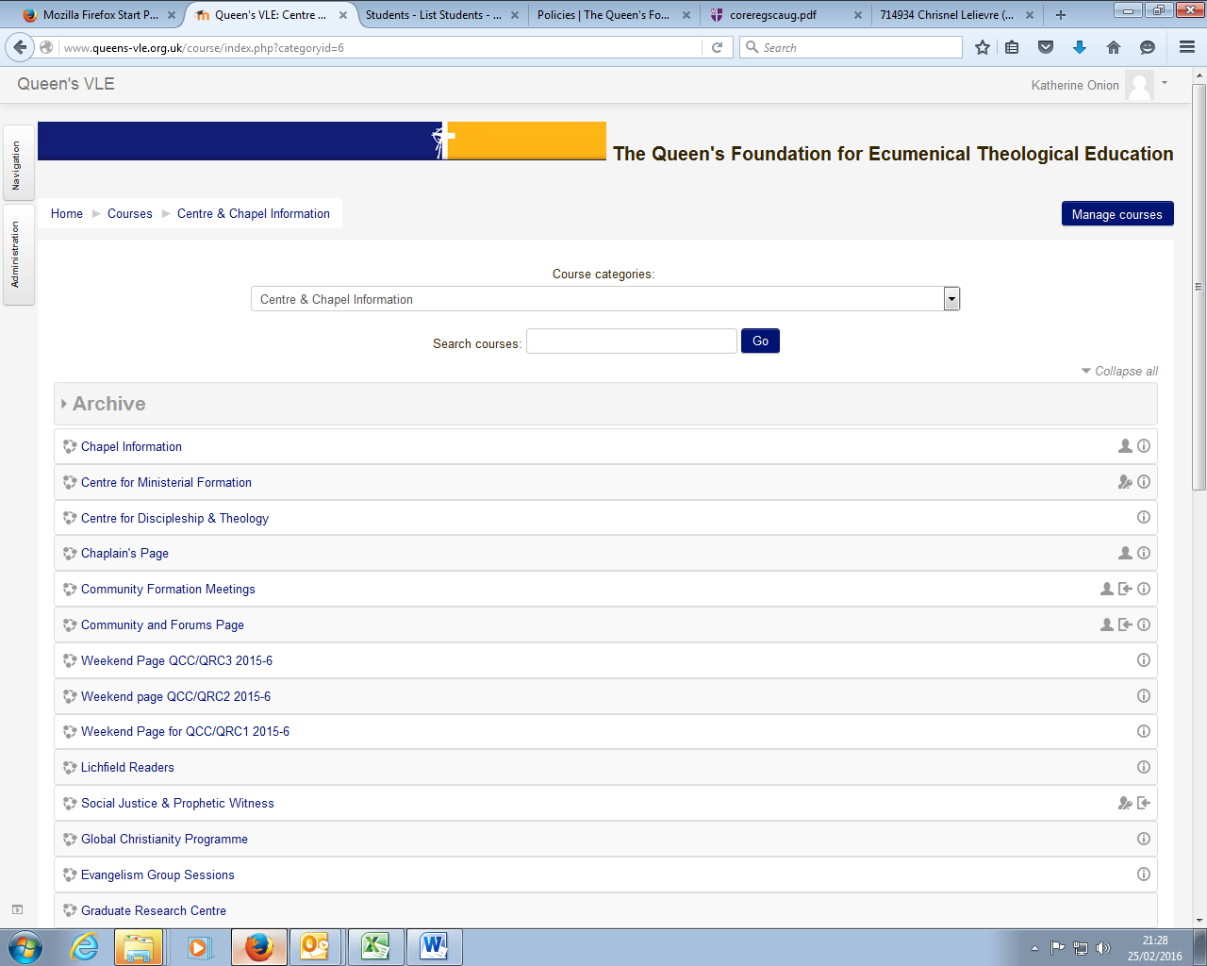.

4. This page looks like this and we are here:
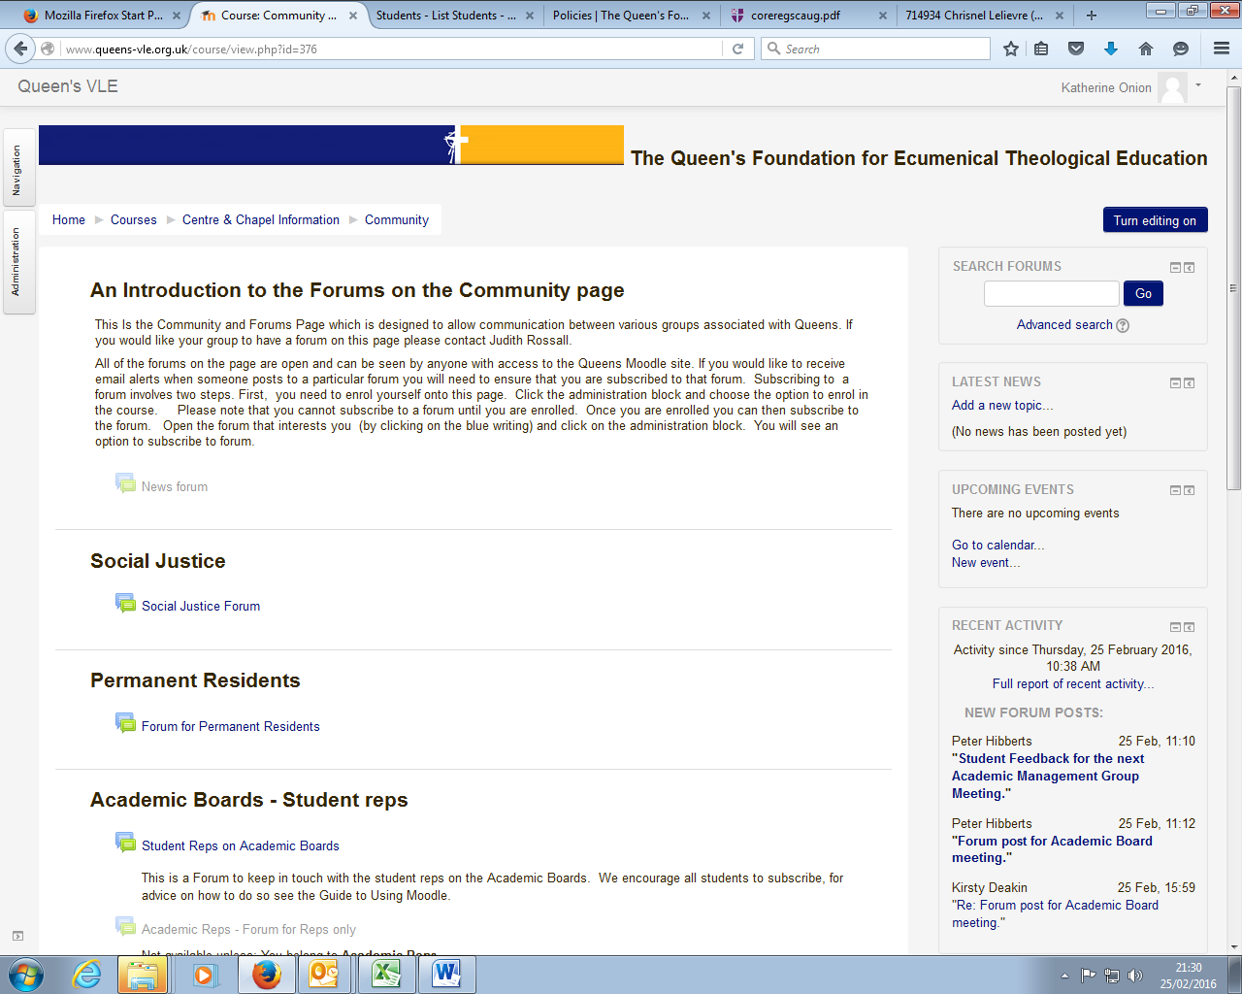

5. There are various topics on here to contribute to:
