Bus Trip to Bristol

27th March 2015

Sign up to come to the New Room and Charles Wesley’s House
and the M-Shed.

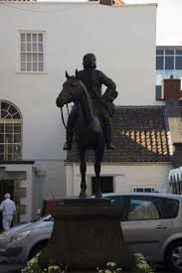

Approx timings:
depart Queen’s 8.45am; return 6.00pm

Charity M | Miriam

