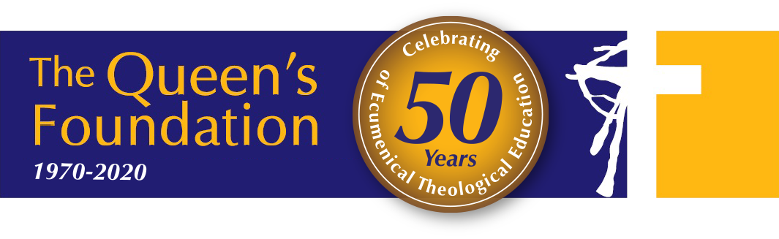Coronavirus and Queen’s
Updated Tues 3rd March 2020
The Church of England and the Methodist Church (as well as other Churches) have issued advice about how local churches should respond to the current situation, and our practice is generally to let that advice be our guide. The advice may change as the worldwide and national situation develops, so this document explains our current response at Queen’s, which seeks to balance appropriate care with the realities of sharing together as a community.
At this stage the Coronavirus itself is not widespread in the UK, and so most of this advice is simply good general hygiene practice. Our approach is therefore ‘precautionary’, but takes seriously the fact that some in our community are at greater risk than others.

General good practice
The two key principles in a community like this are:
- Reducing physical contact; particularly handshaking, hugging etc.
- Reducing multiple contact of the same surface (e.g. door plates).

We can all help by applying the general advice:
- When you cough or sneeze, use a tissue (or your sleeve), not your hand, and then throw the tissue away.
- Practice good hand hygiene – wash your hands regularly and thoroughly with soap and hot water and for 20-30 seconds.
- Don’t touch your face, nose, eyes or mouth with unwashed hands.
- Minimise touching of surfaces like door push-plates and automatic door buttons - where possible use your elbow, shoulder, hip, foot, etc.
- If you have recently travelled to one of the countries listed by the government, and experience symptoms associated with Coronavirus, such as raised temperature, a cough and shortness of breath, or have other concerns, ring NHS 111.
- If you feel unwell (in particular, if you have a raised temperature and/or a cough), don’t come to chapel or other places where people gather.

Worship at Queen’s

Bread at holy communion
- Those assisting in setting up for communion services (setting out bread and cups) will need to make sure they have cleaned their hands thoroughly, using hot soapy water or appropriate sanitising gel.
- The presider and those assisting with distribution should also clean their hands thoroughly using hot soapy water or sanitising gel, before touching the bread. They also need to make sure that as they distribute the bread, they do not touch the hands of communicants – this will prevent any possible cross-contamination.

Wine at holy communion
- We are not suspending the use of the ‘common cup’ at this stage (though we will switch from pottery to silverware, as this is more hygienic). This would have negative symbolic implications and raises the problem of when to ‘restore’ the cup. For now, we will continue our present practice of using common cups, but with an invitation for individual communicants to decide for themselves whether or not to receive the wine on each occasion.
- Please do not take the wine by ‘intinction’ (i.e. by dipping the bread into the wine), as this carries a greater risk of passing on infection than sharing a cup (infection can be passed from hands, onto the bread, then into the wine, and then to the following communicants).
- When individual cups are used for the wine, this also carries risk of cross-contamination when they are being prepared (particularly because they are usually handled by the rim from which people drink). Those setting them up and distributing them must make sure their hands have been thoroughly cleaned. Individual cups also need to be washed very thoroughly after the service (by someone who has already washed their own hands).

Sharing the Peace
Sharing the peace by means of a handshake carries the risk of passing on infection from hand to hand. We suggest that we share the peace using non-contact means (such as using the BSL sign for ‘Peace be with you’).

Signing with the cross using water from the font
This carries some risk of cross-contamination, but because only a few people do this, the risk is relatively small (especially if we are no shaking hands with each other). We encourage people to be aware of this and act accordingly.

Shaking hands with greeters on arrival, and with the preacher and service leader after the service
Again, there is some risk of cross–contamination, so we suggest that for now greeters do not shake hands with people as they arrive, and that leader and preacher do not shake hands with people as they leave (they can still wait at the door).

Eunice Attwood and Mark Earey – 3 March 2020

